**ZipApp - Orange Team**

**Cycle 3 Report**

Authors

Trevor Aupperle

Benjamin Fisk

Camden Davis

Mohab Yousef

COMP 4710 Senior Design

Auburn University Samuel Ginn College of Engineering

April 19, 2024

# 1 - Organization and Format - Trevor

**1 - Organization and Format - Trevor 1**

**2 - System Metaphor and Cycle Intent - Camden 3**

System Metaphor: 3

Cycle Intent: 3

**3 - User Story Descriptions - Trevor 3**

Infrastructure 4

Table 1 - Flutter Migration User Story 4

Table 2 - Operating Systems Check User Story 4

Table 3 - Flutter Facebook Login Package Migration User Story 5

Table 4 - Geoflutterfire Package Migration to Geoflutterfire2 User Story 6

Table 5 - Find an Alternative to Unicorndial Package User Story 6

Table 6 - Strip_Payment Package Migration to Flutter_Stripe User Story 7

Table 7 - Location Package Update User Story 8

UI/UX 8

Table 8 - Figma Mockups User Story 8

Table 9 - Implement UI Changes User Story 9

Functionality 9

Table 10 - Driver Directions Research User Story 10

Table 11 - Driver Directions Implementation User Story 10

Table 12 - Rider ‘On the Way’ Notification User Story 11

Table 13 - Rider Status User Story 12

Table 14 - Rider Recap Screen User Story 12

Table 15 - Drivers Near Me User Story 13

Table 16 - Feedback/Rating System User Story 13

Table 17 - Enhance Feedback and Tips Screen User Story 14

Table 18 - Display Past Trips User Story 15

**4 - Design Documentation - Mohab 15**

Architecture 15

Figure 1 - Diagram of Flow of User’s Actions 16

Structure 16

Interfaces 16

Figure 2 - Diagram of Flow of Remote Data Flow 17

Justification of Decisions 17

Assumptions and Other Dependencies 17

User Interfaces 17

Figure 3 - Payment Methods Screen from Old App Design 18

Figure 4 - Navigation Drawer from Old App Design 18

Figure 5 - Past Activity Screen from Old App Design 19

Figure 6 - Default Tip Screen from Old App Design 19

Figure 7 - Payment Screen from New App Design 20

Figure 8 - Account Screen Information from New App Design 20

Figure 9 - Default Tip Screen from New App Design 21

Figure 10 - Past Activity Screen from New App Design 21

Figure 11 - Ride Details Screen from New App Design 22

Figure 12 - Trip Review Drawer from New App Design 22

Figure 13 - Add Payment Method Screen from New App Design 23

**5 - Lessons Learned - Camden 23**

**6 - Test Results - Ben 24**

General Plan 24

Test Cases 24

Table 19 - Flutter Migration Test Case 24

Table 20 - Geo-Location for Android Test Case 24

Table 21 - Geo-Location for IOS Test Case 25

Table 22 - Flutter_Stripe Package Migration for Android Test Case 25

Table 23 - Flutter_Stripe Package Migration for IOS Test Case 25

Table 24 - User Interface Implementation Test Case 26

**7 - Management Plan - Trevor 26**

General 26

Task Assignments 26

Development Schedule 26

**8 - Memoranda - Mohab 26**

Meeting - January 25th 26

Meeting - January 26th 27

Meeting - February 16th 27

Meeting - February 20th 28

Meeting - March 19th 28

Meeting - March 19th 28

**9 - Source Code - Ben 29**

**10 - Presentation Slides - Mohab 29**

**11 - Previous Cycle Docs and Grade Sheets - Camden 29**

Architectural Spike Documents 29

Cycle 1 Documents 29

Cycle 2 Documents 29

**12 - Sponsor’s Approval and Meetings - Ben 29**

Sponsor Approval Screenshot: 30

Figure 14 - Written Report Sponsor Approval 30

Meeting Coordination and Follow-Up Screenshots: 31

Figure 15 - Meeting Coordination Screenshot 1 31

Figure 16 - Meeting Coordination Screenshot 2 31

Figure 17 - Meeting Coordination Screenshot 3 32

Figure 18 - Meeting Coordination Screenshot 4 32

# 2 - System Metaphor and Cycle Intent - Camden

### System Metaphor:

The system metaphor for this app is similar to a digital “gameday caddy”. Just as a caddy in golf helps players by navigating them around the course while carrying their clubs, this app is a personal navigator through campus on football game days. With a friendly and intuitive interface, users can request rides from golf carts in the area to reach their desired destinations on campus with ease. This creates a quick, efficient, and hassle-free environment for fans from all over.

### Cycle Intent:

The intent for this cycle is to finish the remaining few user interface elements for the driver side of the app, to finish connecting these implementations to the database, and to implement driver directions for the drivers.

# 3 - User Story Descriptions - Trevor

### Infrastructure

### 

### Table 1 - Flutter Migration User Story

|  |  |
| --- | --- |
| **1.0 Flutter Migration** |  |
| Summary: | As a user, I need to be able to use the app to work as intended with no security flaws. |
| Description: | The current Flutter version used in the application from previous teams is Flutter 1.22.5. This is a major concern since Flutter has since released 2 major version updates which include null-safety checking, sunsetting of old iOS versions (iOS 9 and iOS 10), and performance/security improvements. All of these are necessary to ensure the application works as intended and improves the security vulnerability risks. |
| Planned Hours: | **8** |
| Planned Hours this Cycle: | **0** |
| Actual Hours: | **12** |
| Actual Hours this Cycle: | **0** |
| Coder Names: | **Trevor Aupperle** |
| Tester Names: | **Entire Team** |
| Review Names: | **Entire Team** |
| **Status:** | **COMPLETE** |

### Table 2 - Operating Systems Check User Story

|  |  |
| --- | --- |
| **1.2 Operating Systems Check** |  |
| Summary: | As a user, I need to be able to use the app on the most recent versions of iOS and Android operating systems. |
| Description: | After migrating to Flutter 3.0, we need to ensure we can run the app on simulators for different operating systems. |
| Planned Hours: | **1** |
| Planned Hours this Cycle: | **1** |
| Actual Hours: | **8** |
| Actual Hours this Cycle: | **1** |
| Coder Names: | **Ben Fisk, Camden Davis, Mohab Yousef** |
| Tester Names: | **Entire Team** |
| Review Names: | **Entire Team** |
| **Status:** | **COMPLETE** |

### Table 3 - Flutter Facebook Login Package Migration User Story

|  |  |
| --- | --- |
| **1.3 flutter_facebook_login Package Migration** |  |
| Summary: | As a user, I need to be able to login to the app using my Facebook profile. |
| Description: | The Flutter package, flutter_facebook_login, is no longer compatible with Flutter 3.0 and has not been updated in over 4 years. We need to find a new package that is capable of handling facebook sign-ins (we should probably use firebase_ui_oauth_facebook since it is specifically used in conjunction with Firebase and is built by Google). |
| Planned Hours: | **6** |
| Planned Hours this Cycle: | **0** |
| Actual Hours: | **6** |
| Actual Hours this Cycle: | **0** |
| Coder Names: |  |
| Tester Names: |  |
| Review Names: |  |
| Status: | **NOT STARTED** |

### Table 4 - Geoflutterfire Package Migration to Geoflutterfire2 User Story

|  |  |
| --- | --- |
| **1.4 geoflutterfire Package Migration to geoflutterfire2** |  |
| Summary: | As a user, I need specific geolocation features to work so that I can decide where to go and figure out where I am being picked up. |
| Description: | The current geoflutterfire package is incompatible with newer versions of Firebase packages. We need to migrate to the more updated geoflutterfire2 package to handle the dependency issues. To do this, we will need to remove the package flutter_google_places and will need to find a replacement or build our own solution. |
| Planned Hours: | **6** |
| Planned Hours this Cycle: | **0** |
| Actual Hours: | **0.5** |
| Actual Hours this Cycle: | **0.5** |
| Coder Names: | **Ben Fisk** |
| Tester Names: | **Ben Fisk** |
| Review Names: | **Entire Team** |
| Status: | **COMPLETED** |

### Table 5 - Find an Alternative to Unicorndial Package User Story

|  |  |
| --- | --- |
| **1.5 Find an Alternative to unicorndial Package** |  |
| Summary: | As a user, I need an intuitive and friendly user interface to interact with. |
| Description: | There is a Flutter package, unicorndial, that is currently being used as a user interface component. However, it has not been updated in 5 years and no longer works with the new Flutter version. We need to find an alternative or build our own component. |
| Planned Hours: | **4** |
| Planned Hours this Cycle: | **0** |
| Actual Hours: | **0** |
| Actual Hours this Cycle: | **0** |
| Coder Names: |  |
| Tester Names: |  |
| Review Names: |  |
| Status: | **NOT STARTED** |

### Table 6 - Strip_Payment Package Migration to Flutter_Stripe User Story

|  |  |
| --- | --- |
| **1.6 stripe_payment Package Migration to flutter_stripe** |  |
| Summary: | As a user, I need a reliable purchasing system to make purchases on the app for the rides I request. |
| Description: | Currently, the app uses the package stripe_payment to handle payments with the payment provider Stripe. Stripe has migrated to a newly updated package flutter_stripe. Changes need to be made in the app to handle the new package. |
| Planned Hours: | **8** |
| Planned Hours this Cycle: | **0** |
| Actual Hours: | **6** |
| Actual Hours this Cycle: | **0** |
| Coder Names: | **Ben Fisk** |
| Tester Names: | **Entire Team** |
| Review Names: | **Entire Team** |
| Status: | **COMPLETE** |

### Table 7 - Location Package Update User Story

|  |  |
| --- | --- |
| **1.7 Location Package Update** |  |
| Summary: | As a user, I need the app to request to use my location. |
| Description: | Currently, the app uses the package Geolocator to handle getting the user’s location. The old package is poorly implemented and out of date. Either the current package needs to be updated, or changes need to be made in the app to accommodate a new package. |
| Planned Hours: | **8** |
| Planned Hours this Cycle: | **0** |
| Actual Hours: | **12** |
| Actual Hours this Cycle: | **0** |
| Coder Names: | **Ben Fisk** |
| Tester Names: | **Entire Team** |
| Review Names: | **Entire Team** |
| Status: | **COMPLETE** |

### UI/UX

### Table 8 - Figma Mockups User Story

|  |  |
| --- | --- |
| **2.0 Figma Mockups** |  |
| Summary: | As a user, I need an intuitive and friendly interface to interact with. |
| Description: | Currently, the user interface for the app is simply bad. We need to draw up high-fidelity prototypes in Figma to create a better UI/UX system for users. |
| Planned Hours: | **20-24** |
| Planned Hours this Cycle: | **10** |
| Actual Hours: | **35** |
| Actual Hours this Cycle: | **15** |
| Coder Names: | **Trevor Aupperle** |
| Tester Names: | **Entire Team** |
| Review Names: | **Entire Team** |
| Status: | **COMPLETE** |

### Table 9 - Implement UI Changes User Story

|  |  |
| --- | --- |
| **2.1 Implement UI Changes** |  |
| Summary: | As a user, I need an intuitive and friendly interface to interact with. |
| Description: | After mocking up prototypes in Figma and getting them approved by the sponsor, we need to implement the features in the code. |
| Planned Hours: | **12** |
| Planned Hours this Cycle: | **40** |
| Actual Hours: | **86** |
| Actual Hours this Cycle: | **42** |
| Coder Names: | **Ben Fisk, Mohab Yousef** |
| Tester Names: | **Entire Team** |
| Review Names: | **Entire Team** |
| Status: | **IN PROGRESS** |

### Functionality

### Table 10 - Driver Directions Research User Story

|  |  |
| --- | --- |
| **3.0 Driver Directions Research** |  |
| Summary: | As a user (driver), I need to be able to see the best route to take customers to their desired destination. |
| Description: | We need to limit driver routes to streets that can accommodate golf carts legally (35 MPH or less) and also be able to show routes that will likely be “blocked” on game days for vehicles. We will have credentials to get through “blocked” roads. Need to take into account cost algorithms when researching.   Complete research of how we can accomplish this.  **UPDATE**: We are going to attempt to use the Google Roads API to get speed limits for the roads being taken by the drivers. However, there is no API or easy way to create routes to a destination using speed limits as a parameter. We have contacted Google Support to see if a developer is willing to speak with us on the matter. |
| Planned Hours: | **12** |
| Planned Hours this Cycle: | **6** |
| Actual Hours: | **10** |
| Actual Hours this Cycle: | **10** |
| Coder Names: | **Trevor Aupperle** |
| Tester Names: | **Entire Team** |
| Review Names: | **Entire Team** |
| Status: | **IN PROGRESS** |

### Table 11 - Driver Directions Implementation User Story

|  |  |
| --- | --- |
| **3.1 Driver Directions Implementation** |  |
| Summary: | As a user (driver), I need to be able to see the best route to take customers to their desired destination. |
| Description: | We need to limit driver routes to streets that can accommodate golf carts legally (35 MPH or less) and also be able to show routes that will likely be “blocked” on game days for vehicles. We will have credentials to get through “blocked” roads. Need to take into account cost algorithms when researching.   Implementation of research conclusions from user story 3.0 |
| Planned Hours: | **12-16** |
| Planned Hours this Cycle: | **0** |
| Actual Hours: | 0 |
| Actual Hours this Cycle: | 0 |
| Coder Names: |  |
| Tester Names: |  |
| Review Names: |  |
| Status: | **NOT STARTED** |

### Table 12 - Rider ‘On the Way’ Notification User Story

|  |  |
| --- | --- |
| **3.2 Rider ‘On the Way’ Notification** |  |
| Summary: | As a user, I would like a notification about when my driver is going to arrive. |
| Description: | Add a notification for the rider when the driver is on the way to pick them up with an estimated arrival time. Riders should see where the driver is while they are en route. |
| Planned Hours: | **8** |
| Planned Hours this Cycle: | **0** |
| Actual Hours: | 0 |
| Actual Hours this Cycle: | 0 |
| Coder Names: |  |
| Tester Names: |  |
| Review Names: |  |
| Status: | **IN PROGRESS** |

### Table 13 - Rider Status User Story

|  |  |
| --- | --- |
| **3.3 Rider Status** |  |
| Summary: | As a user (rider), I would like to be able to see where I am at in my ride on a map as the drive is occurring. |
| Description: | Once a ride has begun, the rider should see the golf cart location on a map as it moves along the drive. |
| Planned Hours: | **6** |
| Planned Hours this Cycle: | **2** |
| Actual Hours: | 2 |
| Actual Hours this Cycle: | 2 |
| Coder Names: |  |
| Tester Names: |  |
| Review Names: |  |
| Status: | **NOT STARTED** |

### Table 14 - Rider Recap Screen User Story

|  |  |
| --- | --- |
| **3.4 Rider Recap Screen** |  |
| Summary: | As a user (rider), I would like to see a recap of the ride I just took. |
| Description: | Once a ride is over, a screen should be shown to the rider that summarizes their trip and costs. It should also prompt the user for a rating. |
| Planned Hours: | **8** |
| Planned Hours this Cycle: | **4** |
| Actual Hours: | **4** |
| Actual Hours this Cycle: | **4** |
| Coder Names: | **Trevor Aupperle** |
| Tester Names: | **Entire Team** |
| Review Names: | **Entire Team** |
| Status: | **IN PROGRESS** |

### Table 15 - Drivers Near Me User Story

|  |  |
| --- | --- |
| **3.5 Drivers Near Me** |  |
| Summary: | As a user (rider), I would like to see where the nearest drivers are around my current location. |
| Description: | Riders should be able to see current locations of carts around them on a map. |
| Planned Hours: | **6** |
| Planned Hours this Cycle: | **0** |
| Actual Hours: | 3 |
| Actual Hours this Cycle: | 3 |
| Coder Names: |  |
| Tester Names: |  |
| Review Names: |  |
| Status: | **NOT STARTED** |

### Table 16 - Feedback/Rating System User Story

|  |  |
| --- | --- |
| **3.6 Feedback/Rating System** |  |
| Summary: | As a user, I need to be able to give feedback and rate both driver and riders after interactions with them. |
| Description: | Implement a 5-star rating system. |
| Planned Hours: | **10** |
| Planned Hours this Cycle: | **10** |
| Actual Hours: | **20** |
| Actual Hours this Cycle: | **10** |
| Coder Names: | **Camden Davis, Mohab Yousef, Ben Fisk** |
| Tester Names: | **Entire Team** |
| Review Names: | **Entire Team** |
| Status: | **COMPLETE** |

### Table 17 - Enhance Feedback and Tips Screen User Story

|  |  |
| --- | --- |
| **3.7 Enhance Feedback and Tips Screen** |  |
| Summary: | As a user, I need a streamlined and engaging interface for feedback and tips. |
| Description: | The current design doesn't have a feedback screen, which we've found to be less effective. The goal is to design, add a feedback screen and merge it with the tips screen so the rider can be able to rate and tip at the same time. |
| Planned Hours: **6** | **6** |
| Planned Hours this Cycle: **6** | **6** |
| Actual Hours: **6** | **6** |
| Actual Hours this Cycle: **6** | **6** |
| Coder Names: | **Camden Davis, Mohab Yousef, Ben Fisk** |
| Tester Names: Entire Team |  |
| Review Names: Entire Team |  |
| Status: | **COMPLETE** |

### Table 18 - Display Past Trips User Story

|  |  |
| --- | --- |
| **3.8 Display Past Trips** |  |
| Summary: | As a user, I would like to be able to see all of my previous trips as both a rider and a driver. |
| Description: | Create a driver's past trips log and a rider's past trips log. |
| Planned Hours: **12** | **12** |
| Planned Hours this Cycle: **4** | **4** |
| Actual Hours: **4** | **4** |
| Actual Hours this Cycle: **4** | **4** |
| Coder Names: | **Trevor Aupperle, Ben Fisk, Mohab Yousef** |
| Tester Names: | **Entire Team** |
| Review Names: | **Entire Team** |
| Status: | **COMPLETE** |

# 4 - Design Documentation - Mohab

### Architecture

The Zip application is designed to act as a service to bring college football fans to and from stadiums on game days via golf carts. This idea stems from the desire of fans to have a method of transportation into crowded areas where cars are not permitted to drive. The application hinges on user-profile-based interaction. Each user will have their own profile for either reserving rides or offering driving services. A user who logs into their rider profile will have access to reserving and paying for a ride, their ride history, and promotions going on at the current time. A user who logs into their driver profile will have access to their payment settings, their earnings, and previous trips they have driven. Both riders and drivers will have access to their general profile and settings.

See below a diagram depicting the flow of a user’s action inside the Zip app.

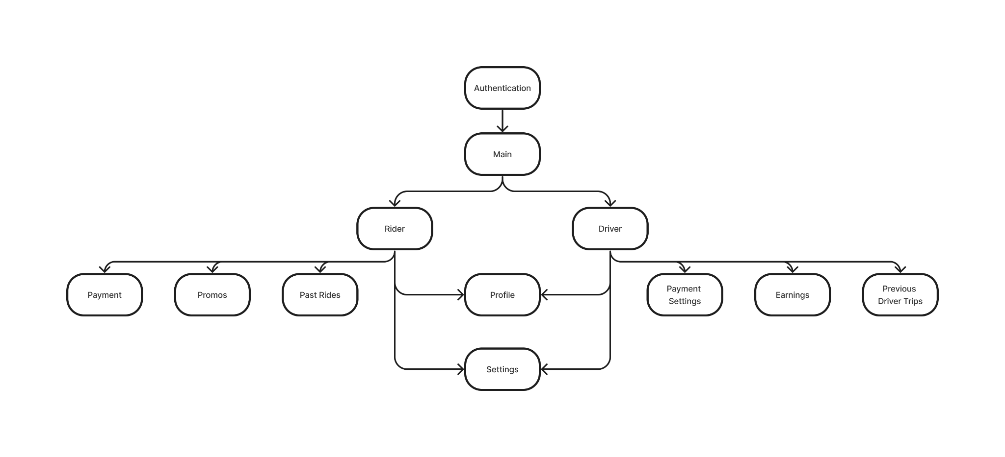

### Figure 1 - Diagram of Flow of User’s Actions

### Structure

The application is built using the Flutter framework. Flutter was built by Google to leverage the Dart programming language to build applications. The combination of Dart and Flutter is designed to allow applications to be installed and run on both the IOS and Android operating systems.

### Interfaces

The application will make use of Google Firebase and Cloud Firestore for database, authentication, and cloud services. It will also be using Stripe to handle transactions between riders and drivers. These services necessitate an internet connection for the app’s functionality.

See below a diagram depicting the interactions between the Zip application, the Firebase cloud services, and the Stripe transaction service.

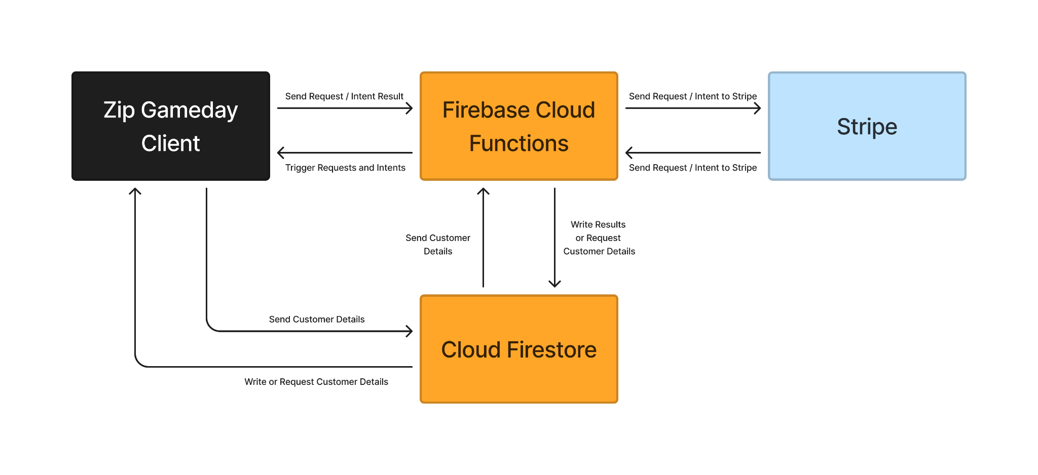

### Figure 2 - Diagram of Flow of Remote Data Flow

### Justification of Decisions

The decision was made to use Flutter because applications made with Flutter can be run on IOS and Android. The decision was made to use Google Firebase and Cloud Firestore because the database and authentication services they provide would be difficult to recreate from scratch given the scope of this project. The decision was made to use Stripe for similar reasons, in addition to the concern of security as it pertains to conducting monetary transactions.

### Assumptions and Other Dependencies

This application depends heavily on an internet connection for all aspects of its operation. From the user’s login to the reservation of rides to the exchange of payment, the app will not function without being connected to the internet.

### User Interfaces

The current user interface is outdated and inconsistent. Therefore, we decided to update the user interfaces using Figma to create high-fidelity prototypes that create a more modern and intuitive interface.

The following is the current design for the payments, profile, history, and default tip screens.

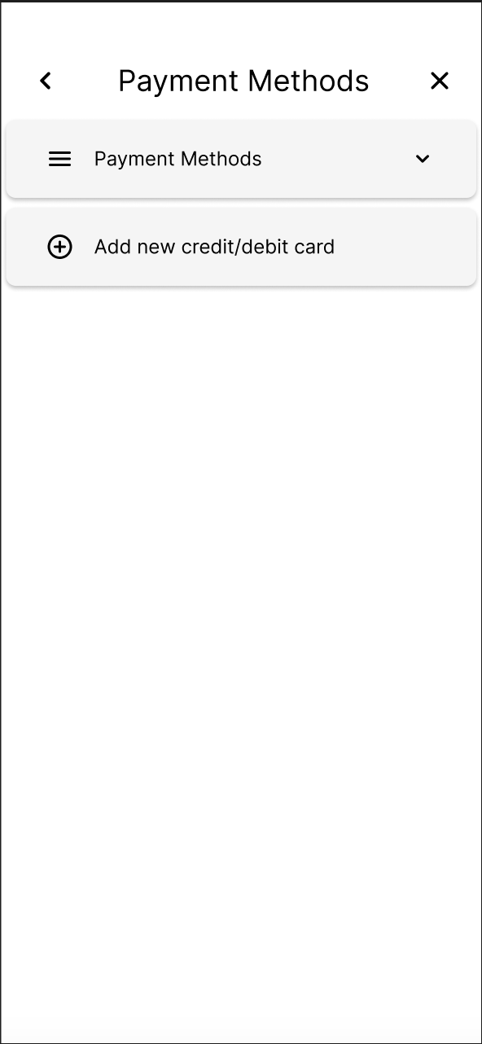

### Figure 3 - Payment Methods Screen from Old App Design

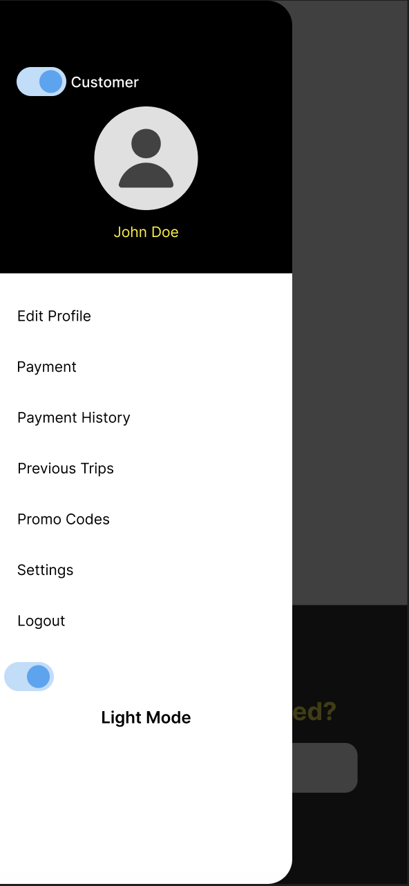

### Figure 4 - Navigation Drawer from Old App Design



### Figure 5 - Past Activity Screen from Old App Design

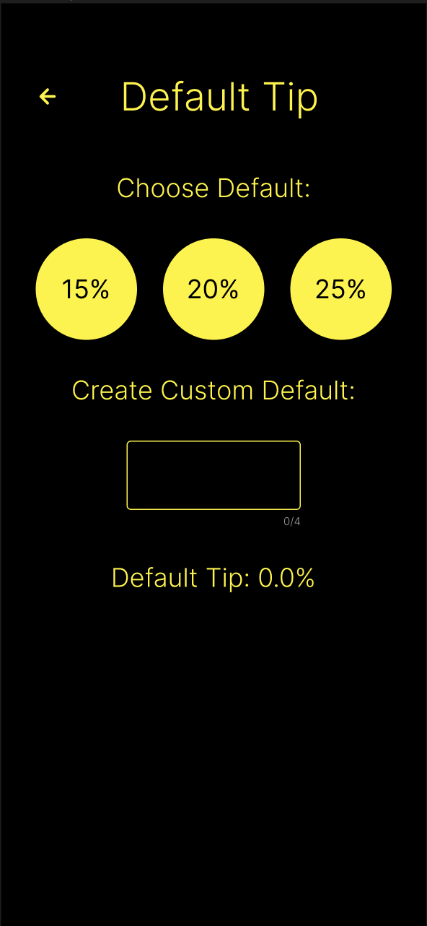

### Figure 6 - Default Tip Screen from Old App Design

The following are the new designs for the profile, activity, default tip, payments, and ratings page.

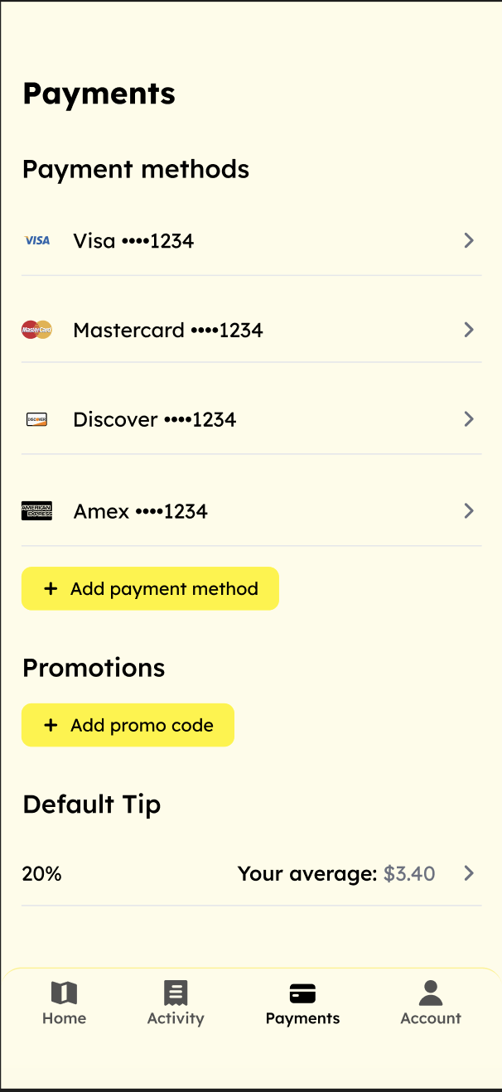

### Figure 7 - Payment Screen from New App Design

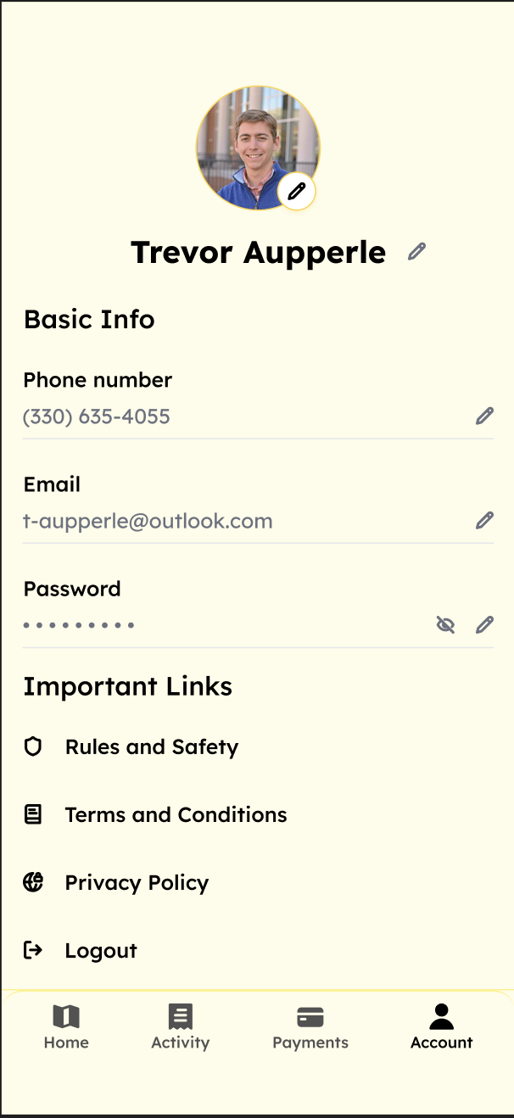

### Figure 8 - Account Screen Information from New App Design

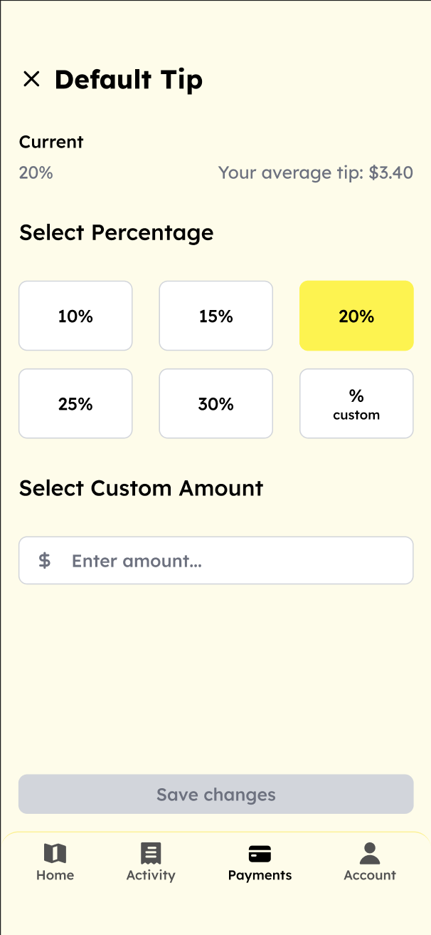

### Figure 9 - Default Tip Screen from New App Design

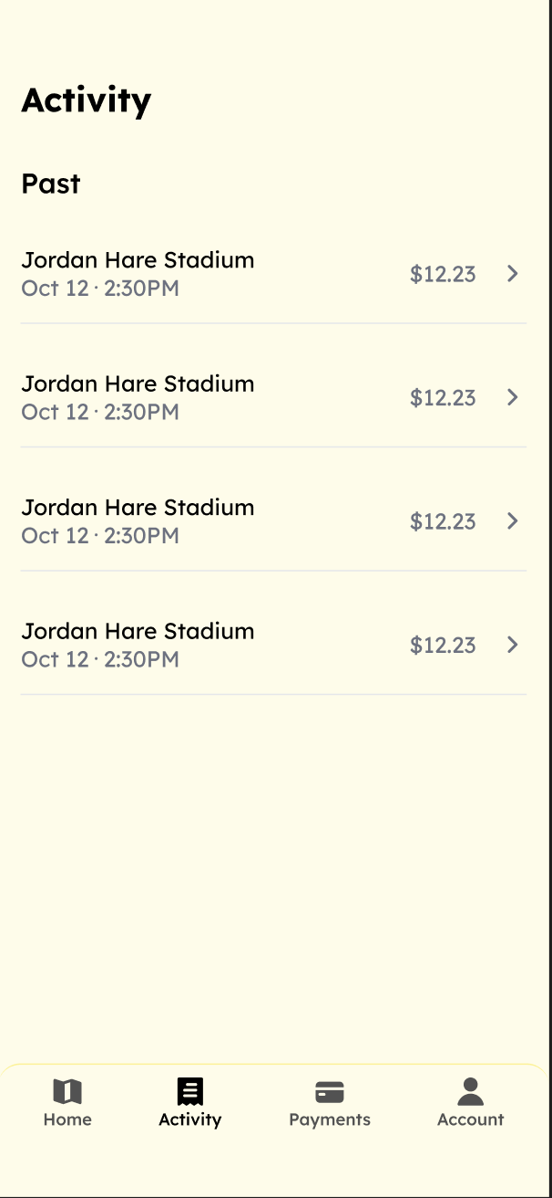

### Figure 10 - Past Activity Screen from New App Design

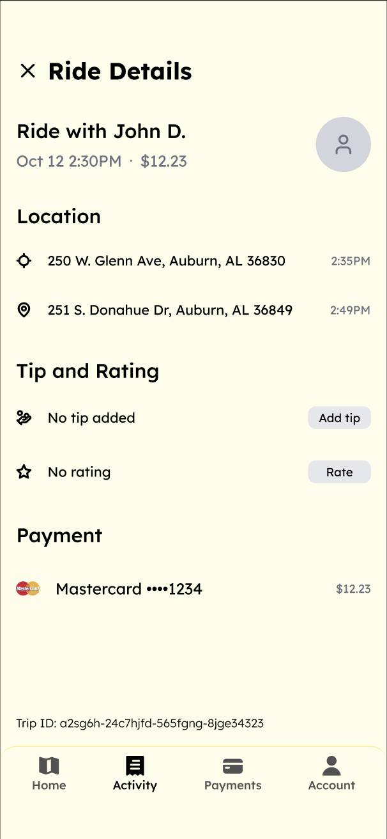

### Figure 11 - Ride Details Screen from New App Design

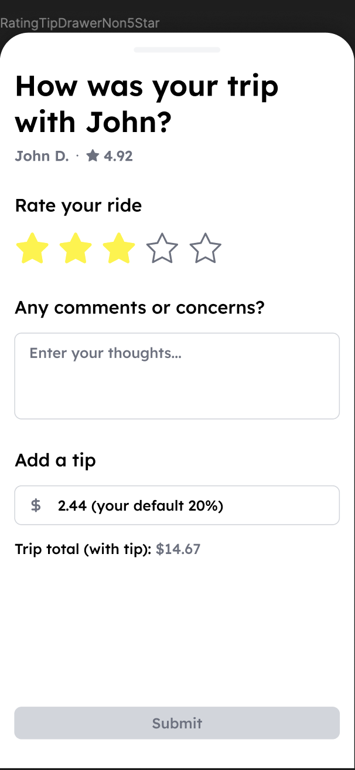

### Figure 12 - Trip Review Drawer from New App Design

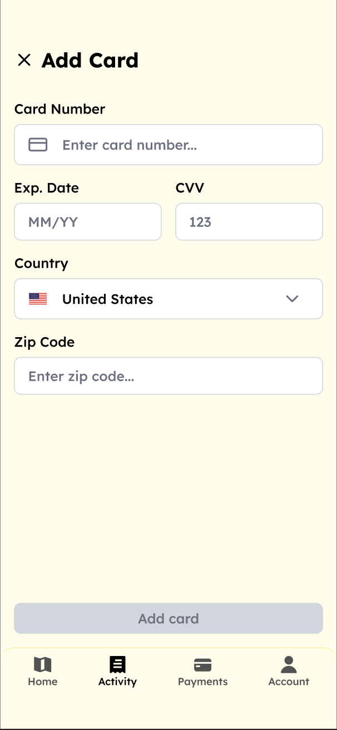

### Figure 13 - Add Payment Method Screen from New App Design

# 5 - Lessons Learned - Camden

Over the course of the architectural spike and the first cycle, we have learned several lessons. One thing we have learned is how important it is to establish working, efficient communication amongst our team members, between our team and the ZipApp blue team, and with the sponsor. Some of the weeks we have had better communication, and those weeks have been more productive as a whole. Therefore we will be focusing a lot on communication moving forward. One of the main challenges we have faced so far is getting the application in its current state (from the previous team’s code base) to simulate correctly. We quickly figured out that the infrastructure for the application was outdated and poorly maintained. Our decision was to upgrade/fix the infrastructure of the application before attempting to make any more features. In making this decision we learned a lot about the migration process to newer versions of packages and SDKs. We also learned through this process that it is better to upgrade to major versions sooner rather than later. Because the other teams before us put these upgrades off, we were forced to fix major areas of the application, which delayed us in attending to our sponsor's goals for this semester. We have learned from this that moving forward, our decisions need to be better documented, and we need to look ahead when making these decisions so that future teams have more support. Finally, throughout the code base, we found many instances of code that were poorly written; commented-out lines of unused code; print statements that print critical information about the state of the app to the console; API keys directly in the code rather than in a .env file; and code that was completely unused. This is unacceptable in software development and it taught us that we need to implement a plan to have code reviews before pushing code to the code base. Therefore, we have decided that code cannot be pushed to the code base without at least one person (preferably two people) reviewing the code. This will ensure the code base is maintained properly, has minimal security risks, and is easily readable for future development.

# 6 - Test Results - Ben

### 

### General Plan

We have decided to handle tests in terms of user stories. We will be handling the testing of each user story as its implementation is completed, and we will make sure to test each user story as a team to ensure thorough coverage.

### Test Cases

### Table 19 - Flutter Migration Test Case

|  |  |
| --- | --- |
| **1.0 Flutter Migration** |  |
| Description: | Ensured the application runs smoothly on the latest versions of Android and iOS. All tests passed, verifying the app's compatibility with Flutter 3.0 and the successful migration of outdated packages. |
| Tester Names: | **Entire Team** |
| **Status:** | **TEST PASSED** |

### 

### Table 20 - Geo-Location for Android Test Case

|  |  |
| --- | --- |
| **1.1 Geo-Location for Android** |  |
| Description: | The application's geo-location feature is functioning as expected on Android devices. We were able to successfully request and use location data to facilitate ride requests and navigation for users. This confirms that the app's integration with the Android operating system's location services is properly configured and operational. |
| Tester Names: | **Entire Team** |
| **Status:** | **TEST PASSED** |

### Table 21 - Geo-Location for IOS Test Case

|  |  |
| --- | --- |
| **1.2 Geo-Location for IOS** |  |
| Description: | The application's geo-location feature is functioning as expected on IOS devices. We were able to successfully request and use location data to facilitate ride requests and navigation for users. This confirms that the app's integration with the IOS operating system's location services is properly configured and operational. |
| Tester Names: | **Entire Team** |
| **Status:** | **TEST PASSED** |

### Table 22 - Flutter_Stripe Package Migration for Android Test Case

| **1.3 Flutter_Stripe Package Migration for Android** |  |
| --- | --- |
| Description: | Migrating the payment system to the most up-to-date package required significant updates to the package management system and overall project. Some problems were encountered in making these updates, but the application is now working on Android. |
| Tester Names: | **Entire Team** |
| **Status:** | **TEST PASSED** |

### Table 23 - Flutter_Stripe Package Migration for IOS Test Case

|  |  |
| --- | --- |
| **1.4 Flutter_Stripe Package Migration for IOS** |  |
| Description: | Migrating the payment system to the most up-to-date package required significant updates to the project. Some problems were encountered in making these updates, but the application is now working on IOS. |
| Tester Names: | **Entire Team** |
| **Status:** | **TEST PASSED** |

### 

### Table 24 - User Interface Implementation Test Case

|  |  |
| --- | --- |
| **1.6 User Interface Implementation** |  |
| Description: | Updating the user interface was required to make the app easier to navigate and intuitive to use for riders. |
| Tester Names: | **Entire Team** |
| **Status:** | **TEST PASSED** |

### Table 25 - Driver Interface Implementation Test Case

|  |  |
| --- | --- |
| **1.6 User Interface Implementation** |  |
| Description: | Updating the user interface was required to make the app easier to navigate and intuitive to use for drivers specifically. |
| Tester Names: | **Entire Team** |
| **Status:** | **TEST PASSED** |

### Table 26 - Firebase Connection Test Case

|  |  |
| --- | --- |
| **1.6 User Interface Implementation** |  |
| Description: | Connecting to the database is an essential function of the app to store and manage user data, and we needed to be sure that the functions used to connect to the database were sound. |
| Tester Names: | **Entire Team** |
| **Status:** | **TEST PASSED** |

# 7 - Management Plan - Trevor

### General

For the management of our project, we will be using Git for version control. We will also be in close contact with the Zipapp blue team, to ensure that no work is duplicated and no conflicts arise.

### Task Assignments

We will be using Jira to communicate and manage tasks for the team. We will also be communicating via email and GroupMe for meetings and other non-technical purposes. We plan on approaching the tasks for this project as a team to begin with, and then assigning tasks to individuals as we see fit based on the ease with which the task can be completed. This will allow everyone on the team to gain an understanding of each task and then make an informed decision on which and how many people should work on that task.

### Development Schedule

Our team will be meeting weekly to discuss our progress, and we will have weekly or biweekly meetings with our sponsor, depending on the sponsor’s wishes. These frequent team meetings will allow our team to stay on the same page, and also to move on to new tasks as old ones are completed. The meetings with our sponsor will allow us to keep them up to date, and ensure that our development of the application aligns with their vision.

# 8 - Memoranda - Mohab

### Meeting - January 25th

**Date**: 01/25/2024

**Time**: 5:30 PM - 6:30 PM

**Attendees**: Trevor Aupperle, Ben Fisk, Camden Davis, Mohab Yousef, Russell Anderson, Paxton Delamar

1. Introductions - we all introduced ourselves including our background and experience.
2. Business Idea - Russell explained where the business idea originated (i.e. working with the football team to drive recruiters around game days on a golf cart)
3. 4 Main Tasks - Russell described the 4 main tasks that he and Paxton would like to see accomplished this semester.
   1. Driver Directions
   2. Rider Side Visuals
   3. Feedback/Ratings
   4. Display Past Trips
4. Infrastructure Concerns - Trevor brought up concerns about the current state of the project’s infrastructure being outdated and incompatible with current operating systems (iOS and Android). Both teams (orange and blue) had been unable to get the app simulated in its current state. Therefore, we needed to spend time updating the infrastructure packages. Russell understood and agreed that was important to fix before moving forward.
5. Questions - We shortly discussed some general questions before ending the meeting.

### Meeting - January 26th

**Date**: 01/26/2024

**Time**: 3:30 PM - 5:00 PM

**Attendees**: Trevor Aupperle, Ben Fisk, Camden Davis, Mohab Yousef, Nico Marthe, Zach Grindle, Jordyn Lewis

1. Discussion - Both the Orange and Blue team for ZipApp met to discuss user stories and how we were going to communicate with each other during the semester. We set processes in plan to avoid confusion about how to merge code when working on the same codebase (i.e we will be doing code reviews in GitHub).

### Meeting - February 16th

**Date**: 02/16/2024

**Time**: 3:30 PM - 4:00 PM

**Attendees**: Trevor Aupperle, Ben Fisk, Camden Davis, Mohab Yousef, Russell Anderson, Paxton Delamar

1. Updates - We discussed our team’s progress on the project since the last meeting.
2. Figma Mockups - Trevor displayed his mockups for the sign-in screen and account creation pane to Russell.
3. Maps API Constraints - Trevor discussed actions to take to solve the problem of routing drivers through roads that have speed limits within the required range.

### Meeting - February 20th

**Date**: 02/20/2024

**Time**: 3:30 PM - 4:30 PM

**Attendees**: Ben Fisk, Camden Davis, Mohab Yousef, Nico Marthe, Zach Grindle

1. Stripe Migration - Ben discussed with Nico the status of the migration to the new Stripe payment package.
2. Repository State - Everyone discussed the state of the repository and which branches need to be reviewed.

### Meeting - March 19th

**Date**: 03/19/2024

**Time**: 4:00 PM - 4:30 PM

**Attendees**: Trevor Aupperle, Ben Fisk, Camden Davis, Mohab Yousef, Russell Anderson

1. Proposed User Interface Changes - Trevor presented his proposed UI changes to Russell for approval.
2. Google Maps API Update - The team discussed the status of finding a working API to evaluate speed limits on Google Maps routes.
3. Driver Interface - The team discussed how to move forward with working on the driver side of the application.

### Meeting - April 4th

**Date**: 04/04/2024

**Time**: 4:00 PM - 4:30 PM

**Attendees**: Trevor Aupperle, Ben Fisk, Camden Davis, Mohab Yousef, Russell Anderson

1. Proposed Driver Interface Changes - Trevor presented his proposed driver-side UI changes to Russell for approval.
2. Admin Portal Changes - The team discussed the possibility of changing the admin portal to be password-protected and more intuitive for administrative users.

# 9 - Source Code - Ben

Link to source code: <https://github.com/TrevorAupperle/ZipApp>

# 10 - Presentation Slides - Mohab

Link to Cycle 2 presentation slides: [Cycle 2 Presentation](https://docs.google.com/presentation/d/1PeVAUNzRWHkbLoQdkD9oEnWk3hPKSEDEijS96aquiCQ/edit#slide=id.p)

# 11 - Previous Cycle Docs and Grade Sheets - Camden

### Architectural Spike Documents

Link to Architectural Spike written report: [Architectual Spike Written Report](https://docs.google.com/document/d/1WRNkKajNEMYdYxBbfbjR5Rqe5esGHgPbktcpjR-BLbU/edit?usp=sharing)

Link to Architectural Spike Presentation Slides: [Architectural Spike Presentation](https://docs.google.com/presentation/d/1N78ejkcyI44O5OONpUMrGQVxHCDfD1L9gJ7WWRkRGNs/edit?usp=sharing)

### Cycle 1 Documents

Link to Cycle 1 Written Report: [Cycle 1 Written Report](https://docs.google.com/document/d/1g1AKNhQXX_1Lwq1QllxK5mynQcRyydBmAaiUCko5Zh8/edit)

Link to Cycle 1 Presentation Slides: [Cycle 1 Presentation](https://docs.google.com/presentation/d/1_TPpy5pChl_vygMDl0XQanEzTIWlWjcNdDdWnyf1BJM/edit#slide=id.p)

### Cycle 2 Documents

Link to Cycle 2 Written Report: [Cycle 2 Written Report](https://docs.google.com/document/d/1-5keJG_fZlSID1mDU9zAULweH-hVMu9lGVJOBgkot2E/edit)

Link to Cycle 2 Presentation Slides: [Cycle 2 Presentation](https://docs.google.com/presentation/d/1PeVAUNzRWHkbLoQdkD9oEnWk3hPKSEDEijS96aquiCQ/edit#slide=id.p)

# 12 - Sponsor’s Approval and Meetings - Ben

### Sponsor Approval Screenshot:

### 

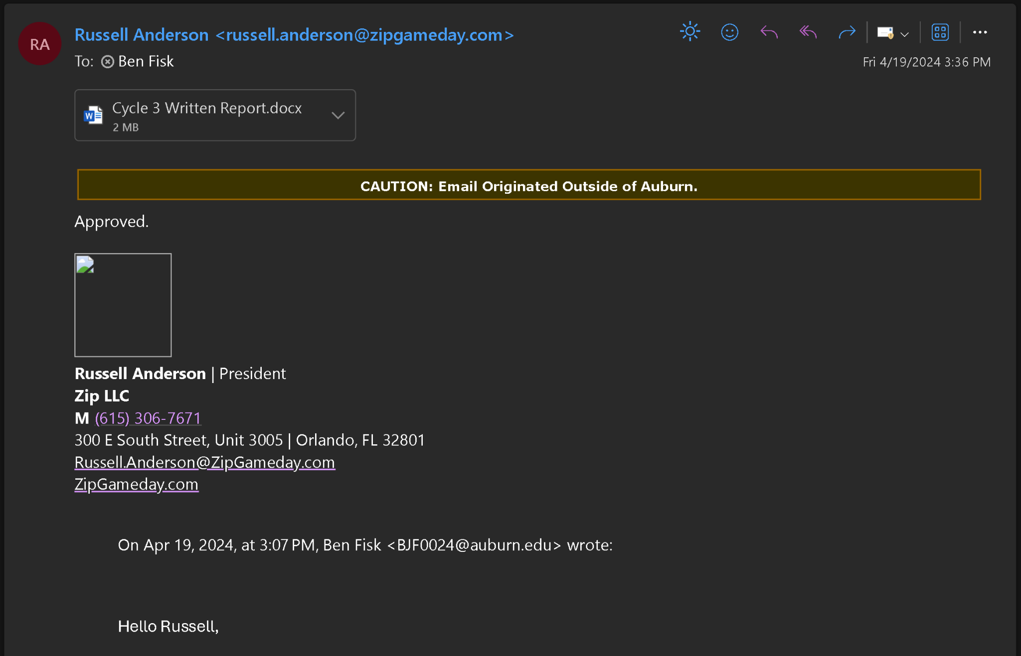

### Figure 14 - Written Report Sponsor Approval

### Meeting Coordination and Follow-Up Screenshots:

### 

### 

### Figure 15 - Meeting Coordination Screenshot 1

### 

### 

### Figure 16 - Meeting Coordination Screenshot 2

### 

### Figure 17 - Meeting Coordination Screenshot 3

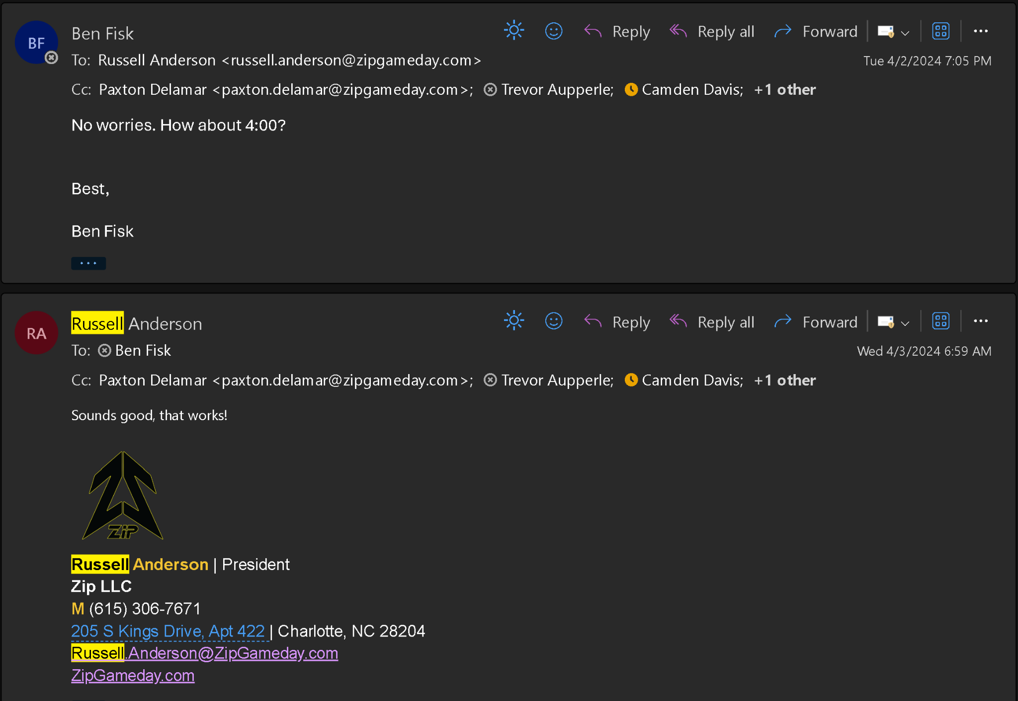

### Figure 18 - Meeting Coordination Screenshot 4